When plotting an lm object in R, one typically sees a 2 by 2 panel of diagnostic plots, much like the one below:

set.seed(1)

x <- matrix(rnorm(200), nrow = 20)

y <- rowSums(x[,1:3]) + rnorm(20)

lmfit <- lm(y ~ x)

summary(lmfit)

par(mfrow = c(2, 2))

plot(lmfit)

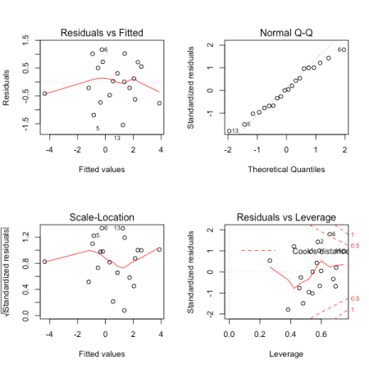

[This link](https://data.library.virginia.edu/diagnostic-plots/) has an excellent explanation of each of these 4 plots, and I highly recommend giving it a read.

Most R users are familiar with these 4 plots. ***But did you know that the* plot() function for lm objects can actually give you 6 plots?** It says so right in the documentation:

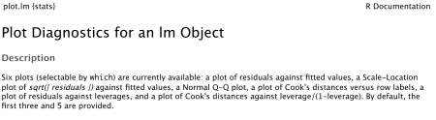

We can specify which of the 6 plots we want when calling this function using the which option. By default, we are given plots 1, 2, 3 and 5. Let’s have a look at what plots 4 and 6 are.

***Plot 4 is of*** [***Cook’s distance***](https://en.wikipedia.org/wiki/Cook%27s_distance) ***vs. observation number (i.e. row number).*** Cook’s distance is a measure of how influential a given observation is on the linear regression fit, with a value > 1 typically indicating a highly influential point. By plotting this value against row number, we can see if highly influential points exhibit any relationship to their position in the dataset. This is useful for time series data as it can indicate if our fit is disproportionately influenced by data from a particular time period.

Here is what plot 4 might look like:

plot(lmfit, which = 4)

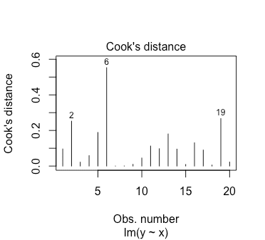

***Plot 6 is of Cook’s distance against (***[***leverage***](https://en.wikipedia.org/wiki/Leverage_(statistics))***)/(1 – leverage).*** An observation’s leverage must fall in the interval , so plotting against (leverage)/(1 – leverage) allows the x-axis to span the whole positive real line. The contours on the plot represent points where the absolute value of the standardized residual is the same. On this plot they happen to be straight lines; the documentation says so as well but I haven’t had time to check it mathematically.

Here is what plot 6 might look like:

plot(lmfit, which = 6)

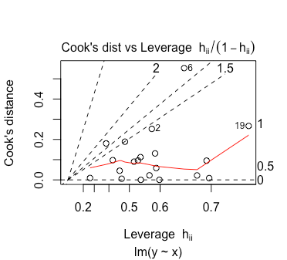

I’m not too sure how one should interpret this plot. As far as I know, one should take extra notice of points with high leverage and/or high Cook’s distance. So any observation in the top-left, top-right or bottom-right corner should be taken note of. If anyone knows of a better way to interpret this plot, let me know!